Rank-order tournaments, probability of winning and investing in talent: Evidence from Champions League qualifying rules

Colin Green (Lancaster University)
Fernando Lozano (Pomona College & IZA)
Rob Simmons (Lancaster University)

Abstract

Tournaments are hard to test empirically because it is difficult to observe both a principal’s rewards and agent’s effort. A sector where both can be observed is the sports industry and it is unsurprising that tests of tournament theory have covered golf and tennis. We follow this direction and analyse how a change in the probability of winning a tournament affects an agent’s effort. Specifically, we use the qualification rules for entry into the group stage of the UEFA Champions’ League which is a multi-national European football competition for top League clubs across Europe. Our dependent variable is total team payroll in a given season and we have club panel data for four seasons. Our focus independent variable is domestic rank in previous year interacted with number of available places in the Champions’ League. Our results suggest that increasing the probability of winning the tournament, by increasing the number of slots that a national league gets in the Champions League leads to increases in investment in talent ex ante. This effect is positive and statistically significant and is largest among the teams that are marginally affected by the change in the rules, those who in the previous season barely qualified or just failed to qualify. This suggests that changes in prize structure leads to changes in investment decisions amongst those clubs most affected at the margin. More generally, this provides support for the idea that in settings where ability can be manipulated, higher prizes increase investment in talent.

Acknowledgements
We thank Bernd Frick for supplying the transfermarkt team payroll data used in this paper.
* Preliminary Draft
Introduction
Rank order tournaments are commonly used in different organizations where the ordinal rank of output determines agents' compensation, yet output is only determined ex-post and in part by some random component. Notwithstanding the fact that under certain assumptions these tournaments theoretically achieve first-best agents' effort, tournaments are hard to test empirically because it is difficult to observe both a principal’s rewards and an agent’s effort. A sector where arguably both can be observed is the sports industry. As a result a body of research has developed specifically using golf and tennis where tournaments have ex ante fixed prize structures. One difficulty with this approach is that little variation in prize structure exists across time within a given tournament. As a result econometric identification of prize effects on effort is largely driven by either across tournament variation (Ehrenberg and Bognanno, 1990) or within tournament variation in the pool of competitor survival at different levels of the tournament in the presence of paired contests (Sunde, 2009). One concern with using across tournament variation is that it may conflate prize money with prestige. We add to this literature by using a novel source of time variation in prize structure within given sporting tournaments, and examining how this influences a measure of agent’s ex ante decisions. Specifically, we use the qualification rules for entry into the group stage of the UEFA Champions’ League, which is a multi-national European soccer competition for top League clubs across Europe. We use data from fourteen different national leagues to test whether team effort responds to a change in the number of slots that are assigned from the Champions League qualification rules to teams from each league, and thus the probability of winning the tournament.
The previous empirical literature has emphasised effort responses to prizes and treated selection on ability into tournaments as a confounding factor to be controlled for (Ehrenberg and Bognanno, 1990; Coffey and Maloney, 2010; see Frick and Simmons, 2008 for a survey). We adopt a different approach and specifically examine agents (clubs) responses to different prize spreads by trying to influence the ability of their workers (teams). Specifically, we examine the effect of variation in prizes, provided by within-national league time variation the number of slots each country gets for the Champions League, on investment in talent at the beginning of a season.
Our results suggest that increasing the probability of winning the tournament, by increasing the number of slots that a national league gets in the Champions League leads to increases in investment in talent ex ante. This effect is positive and statistically significant and is largest among the teams that are marginally affected by the change in the rules, those who in the previous season barely qualified or just failed to qualify. This suggests that changes in prize structure leads to changes in investment decisions amongst those clubs most affected at the margin. More generally, this provides support for the idea that in settings where ability can be manipulated, higher prizes increase investment in talent.
- Background
For soccer teams in Europe, qualifying to the UEFA Champions League is a high stakes tournament, as the rewards usually run well into the millions of Euros. For example, for the 2012 to 2013 tournament, the Italian side Juventus earned more the 65 million dollars alone from participating in this tournament. This combined with the rank order nature of qualification into the Champions League leads to large discontinuities in club revenue. The difference between qualification and non-qualification leads to a large prize spread across two rank positions in the league table. This, and any variation in the number of qualification places, will influence club incentives over several dimensions including pre-season investment decisions. More generally, a number of empirical papers have shown how team payroll spending is correlated with League ranking and hence the likelihood of qualifying for the Champions’ League (Simmons and Forrest, 2004; Frick, 2013; Szymanski, 2013). In addition, Shokkaert and Swinnen (2013) show that outcome uncertainty has increased within the Champions League after the introduction of the new qualifying rules that we will exploit in our empirical approach.
A simple two-player tournament model can be summarised concisely as follows (our presentation closely follows Connelly et al. 2014). Denote q_{j} as output, μ_{j} as effort or investment (where these terms are used synonymously) and ε_{j} as luck. Then q_{j} = μ_{j} +ε_{j} for contestant j . If the cost of effort function is given by C(μ) then the expected payoff from winning a prize W₁ with probability P and retaining a sum W₂ from losing is:
P[W₁ - C(μ)] + (1 – P)(W₂ - C(μ)] = P(S) + W₂ - C(μ)
where S is the prize spread, W₁ - W₂. Note that this function assumes that each player has the same cost of effort (investment) function. Note also that the ability of contestants is uniform. Our empirical analysis needs to relax both of these assumptions. Labelling the two contestants as j and k, the probability that j wins is:
P = Prob(q_{j} > q_{k}) = prob(μ_{j} – μ_{k} < ε_{j} – ε_{k})
The first order and second order conditions for a maximum chosen over μ for agent i are:
∂P/∂μ_{i}(S) - C′(μ_{i}) = 0
∂²P/∂μ_{i} ²(S) - C″(μ_{i}) = 0
Hence optimal contestant effort or investment is determined by how the change in effort or investment influences the probability of winning the tournament. The effort or investment level is also a decreasing function of marginal cost of effort (investment). Two testable propositions follow from this simple theory. First, an increase in prize spread leads to increased effort (investment). Second, only differences in prize (the prize spread S) matter for choice of effort or investment; the absolute size of win value plays no role.
McLaughlin (1988) extended the two player model above to n players. Other things equal, the probability of winning for a given participant is reduced as the number of players rises. It is not clear in this extension that the optimal prize spread will increase as the tournament size rises. It is also unclear whether agents’ efforts will remain constant as tournament size increases. This is germane to our application. The effect of one’s own effort on the probability of winning is diluted by a greater tournament size and to induce optimal incentives the prize spread should increase with tournament size. Alternatively, if a contestant perceives that there is an increased effect of extra effort on the chance of winning then that should induce greater motivation and increased effort or investment.
Among the theoretical features of tournaments, agent's effort should be positively related to the size of the winner's prize, yet the probability of winning that prize has an ambiguous effect on effort (Lazear and Rosen, 1981). The first result has been tested empirically in the field, for example by Erhenberg and Bognanno (1990) using the PGA tournament. The second result, how a change in the probability of winning the tournament affects outcome remains unexplored in the field, although has been tested empirically in controlled classroom experiments. Schotter and Weigelt (1992) test how agent heterogeneity and affirmative action determines effort, and their results show that when heterogeneity is small, effort increases by the disadvantaged players, yet they also show that when heterogeneity is large, effort by the disadvantaged players decrease.
Similar to Schotter and Weigelt’s (1992) asymmetric tournament above, an important feature of the Champions League tournament is that a change in a team’s probability of qualification should have a greater effect on the incentives of those agents whose marginal return from increasing payroll is highest. The teams that normally finish at the top of the domestic league table, and those near the bottom, have little marginal benefit from raising their effort as the number of Champions’ League places changes. Indeed, teams that marginally qualified or failed to qualify for the competition should vary their spending by the largest amount as the number of Champions League places increases. Importantly for our empirical design, the number of teams from each national League that qualifies into the Champions League is determined by the UEFA Coefficient, which is in turn calculated based on previous Champions League performances of other teams in a given League. This coefficient is time varying, but orthogonal to current season investment in the playing squad. In the case of Italy for example, the number of qualifying teams varied during the last ten years between three and four. A greater number of slots implies a higher probability of qualification. Again, our empirical prediction is that changes in the number of available slots will mostly affect those teams effectively competing for third to fifth places in the domestic League.
- Data and Descriptive Statistics
We use data for fourteen leagues from 2006-2007 to 2013-2014 seasons. As payroll data is not publicly available we use team valuation from transfermarkt.de for the seasons 2006-2007, 2008-2009, 2010-2011 and 2013-2014. The, ranking from each country, qualifying teams and payoffs from participating in European competitions are obtained from the UEFA Financial Reports (Available in http://www.uefa.com/uefa/management/finance/index.html), and the total point and table placement from ESPN FC. The leagues in our sample are England, Spain, Italy, France, Germany, Turkey, Netherlands, Portugal, Belgium, Greece, Scotland, Poland, Austria, and Switzerland. The data on each league rankings comes from ESPN FC.
The Champions League is divided into six stages: the first stage is composed of a double round-elimination stage with four teams, the champions of the four lowest ranked federations. The second stage will include the two winners from the first stage, plus the champions of the federations ranked 17-49 (34 teams). The third round will include the seventeen winners from the previous round, the champions from federations 14-16, the runners up from federations ranked 7-15 and the third place from federation ranked 6 (30 teams). The playoff round is composed of a double-stage round robin with the 15 winners of the previous round, two third place teams from federations ranked 4-5 and three fourth place teams from federations 1-3 (20 teams). Finally, the group stage is composed of the 10 winners from the previous round, the champions from federations 1-13, the runner us from federations 1-6, and the third place of federations 1-3. This is followed by the knockout phase where the 8 winners and runner ups of the group stage meet (32 teams).
The further a team advances in the Champions League, the higher the team revenue will be. While earnings in the qualifying rounds are relatively modest, earnings on the group phase and after are quite substantial. Teams who fail to qualify to the group stage earn 150,000 euros if the play in the first stage, 200,000 euros if they play in the second stage, and 250,000 if they are in the third stage playoff. The big returns start with the group stage. For example, for the 2012-2013 tournament a total of 904 million euros was distributed to teams participating in the group stage under the following formula. First, 495 million euros are distributed based in the following rule: teams playing in the group stage receive a stage fee of 8.6 million euros, plus 1 m euros for every win and .5 m euros for every draw. Teams that qualify to the knock out phase earn an additional 3.5 million euros, teams that further qualify to the quarterfinals earn an additional 3.9 million euros, teams making it to the semi-final earn an additional 4.9 million euros, and the winner of the final nets 10.5 m euros, while the runner up earns 6.5 million. In addition 409 million euros are distributed based on each team’s market pool. (source: http://www.uefa.org/management/finance/news/newsid=1979893.html) Note that the total amount for the 2013-2014 season increased from 904 million euros to 1.285 bn euros. Figure 1 shows the evolution of payments to teams from each of the top five leagues from 2006 to 2011. Notice that while the trend is increasing on average for all leagues, the largest increase in absolute terms is for the smaller leagues that are all collapsed in one category or England.
Table 1 presents the number of spots as defined above from each of the fourteen leagues from 2005-2013. England, Spain and Germany are the leagues with the most spots with four spots each, yet while the first two leagues do not change the number of spots during this time period, Germany adds one. In contrast Italy and Portugal experience more variation during this time period, Italy flows move between four and three, while Portugal between one and three. Not surprisingly, the smaller leagues have less spots, and, for example, Scotland and Switzerland experience variation as well with movements between one and two slots.
Figure 2 shows the evolution of team valuations for the top 5 leagues, and collapsing all other leagues into a new category. As with earnings from the Champions League, these valuations are increasing the most for the category with all smaller countries collapsed and for England. This is prima-facia evidence that higher team payroll (as measured by team valuation) is associated with higher earnings and access to the Champions League, but of course this association may very well be driven by league heterogeneity or by other secular trends in the soccer landscape.
- Empirical Specification
Our empirical specification relies on the fact that the UEFA coefficient, and thus the number of spots each team gets in the Champion League, is determined by the outcome in the Champions League by each country’s teams in the past five years of competition. As such, any single team in a given year only influences its countries’ coefficient marginally. Moreover, changes in the number of marginal Champions League slots for a given league should only affect the decisions of teams operating at the margin of qualification. For example, in the Spanish league an extra spot will not directly change the investment decisions of either Real Madrid or Barcelona, the teams whose performance most influences Spain’s coefficient. Any incentive effect will instead be concentrated on the decisions of the teams just below these such as Atletico de Madrid or Real Sociedad. In a given calendar year, teams are restricted to just two opportunities to engage in player trades for cash (transfers). These opportunities, known as transfer windows comprise July and August, mostly before the next season starts, and January, half way through the season in most European countries. Most transfers occur in the close season. This is when teams can release and hire players in a process of team rebuilding. New contracts for existing players can be signed at any time but again tend to be settled in the close season.
In line with previous literature we predicted that teams with higher payrolls will achieve higher league positions, ceteris paribus, and will have greater probability of gaining entry into the Champions’ League. Simmons and Forrest (2004) and Frick (2013) offer evidence in support of this proposition for a number of European football leagues. Szymanski (2013) shows that teams that have greater spending on transfer fees also have higher league positions. The team valuations that we use are based on independent expert assessments of individual player values, and incorporate potential transfer fees. Frick (2011) argues that these market valuations are proportional to a subset of observed player salaries in the Bundesliga and we expect this proportionality to hold across European leagues.
Thus, our main specification estimates the following equation:
$$P_{it}=β_{0}{+β}_{1}I_{it-1}^{1-2}{+β}_{2}I_{it-1}^{1-2}*{CH}_{t}{+β}_{3}I_{it-1}^{3-5}{+β}_{4}I_{it-1}^{3-5}*{CH}_{t}{+β}_{5}I_{it-1}^{6+}{+β}_{6}I_{it-1}^{6+}*{CH}_{t}+μ_{i}+ε_{it}$$
where P_{iy} is the response variable that measures total team's i payroll in year t, $I_{it-1}^{1-2}$ represents that team i finished in the top two spots in year y-1, $I_{it-1}^{3-5}$ represents that team i finished in either third, fourth or fifth place in year y-1, and $I_{it-1}^{6+}$ represents that team i finished outside the top 5 spots in year y-1. CH_{t} represents the number of spots a team’s League has in the Champions League in year y. This equation is also estimated with team fixed effects and each observation is weighted by the inverse of the square root of the number of observations in each league.
In addition, instead of estimating how an extra spot in the Champions League changes team’s incentives using the team’s absolute rankings we instead estimate a model that measures how far is each team at the beginning of each season from qualifying to the Champions League. To do so we estimate:
P = α₀ + α₁Dev0 + α₂Dev1-3 + α₃Dev4-6 + α₄Dev6plus+ α₅Dev0*Add1 + α₆Dev1-3*Add1 + α₇Dev4-6*Add1 + α₈Dev6plus*Add1 + α₉Dev0*Minus1 + α₁₀Dev1-3*Minus1 + α₁₁Dev4-6*Minus1 + α₁₂Dev6plus*Minus 1 + u
where Dev0 stands for a variable that takes a value of one for teams that qualified to the Champions League last year, Dev1-3 is a variable that takes a value of one for teams who finished one, two or three places away from qualifying to the Champions League, Dev4-6 is a variable that takes a value of one for teams that finished within four to six spots from the Champions League, and Dev6plus takes a value of one if a team finished farther than sixth place from qualifying to the Champions League. Add1 is a variable that takes a value of one if the team’s country number of spots increased the in the Champions League, and Minus1 is a variable that takes a value of one if the team’s country number of spots in the Champions League decreased, while u is a random error term. As with equation 1, this equation is also estimated with a team fixed effects and each observation is weighted by the inverse of the number of observations in each league.
- Results
Estimates of equation (1) are presented in Table 2. The first column presents estimates for all 14 countries together, and includes team fixed effects. Recall that the coefficients of interest are the interaction terms between place the team finished in the league last year and the number of spots that each league has in the Champions League. Also recall that the omitted category is all teams that finished either first or second. The results from column one suggest that an increase in the number of spots each league gets in the Champions League increases team payroll across all teams in the league. The magnitude is largest when the team finished the previous season within the seven top league spots. One challenge of the results in Table 1 is that leagues differ not only in the number of spots they get for the Champions League, but also in other important dimensions such as the number of teams in the league, the market size of the teams in the league, or the distribution of payroll within the league. To control for this heterogeneity, column 2 instead presents the estimates of equation (1) with a variable using the lag payroll for each team, and country fixed effects. To control for the dispersion of payroll within each league, column three adds a variable showing the distance of each team’s payroll from the league’s average payroll. The results are consistent across all three columns, and extra Champions League spot is associated with larger payroll across all teams, but again the largest magnitude is among the top seven teams, those that we hypothesize are the most affected in the margin by the extra spot.
To further explore how payroll is associated with the available Champions League qualification places , Table 3 shows the estimates for equation (2) where instead of the rank of the team in the table the previous season we measure the number of spots in the league table that each team is from qualifying. That is, all teams that qualify to the Champions League in the previous year get a value of zero, and the following teams are ordered cardinally from 1 to N (where N is the number of teams in the league minus the number of teams that qualified on the previous year). We interact this variable with whether the League had an extra spot, or whether the League had a spot less. The columns in this table replicate those in Table 2 where the first column has team fixed effects and the second and third columns have country (League) fixed effects. The omitted category is teams who in the previous season qualified to the Champions League and there was no change in spots. Notice, that while the coefficients are not statistically significant different from zero, all the coefficients of interactions between an extra spot and distance from qualifying are positive in sign and largest in magnitude for teams that finished within five spots from qualifying to the Champions League. In contrast, the coefficients of interaction between an extra spot and teams who qualified to Champions League are quite small in magnitude. Further, the coefficient estimate of CHX1-3 Away is marginally statistically significant at 10 per cent in both country fixed effects specifications.
In Table 4 we estimate equation (2) again, but instead we measure the deviation in points from qualifying to the Champions League in the previous season. Again, there is no change in payroll for the teams who qualify to Champions League that earn an extra spot the following season. Yet, among teams that finish within six points from qualifying to the tournament, payroll increases by 20 percentage points with an added spot in the Champions League. Notice that payroll also increases with an extra spot for teams who finished beyond fifteen points from qualifying, but the magnitude is much smaller. Importantly as well, while the coefficient estimates of an extra spot are mostly positive, the estimates for the coefficients when a spot is taken away from a league are generally negative and statistically significant for teams in the bottom of the table. For example, decreasing the number of Champions League spots allocated to a league results in a decrease in payroll by the teams who in the previous season qualified for the Champions League, and also by the teams who finished farther away from qualifying. That is, when one measures the distance that a team faces to qualify for the Champions League in terms of points, a higher probability of qualifying (and winning our conceptual tournament) results in larger payroll and a lower probability of qualifying (and hence winning the conceptual tournament) results in smaller payoffs.
- Conclusion
In this paper we use the qualifying rules from the Champions League to understand how agents react to an exogenous change in the probability of winning a rank-order tournament. Our results suggest that increasing the number of spots that a league has for its teams to qualify into the Champions League results in higher payroll by teams that in the previous season fell short of qualifying. The estimates are larger for teams who barely failed to qualify and they decrease for teams that are farther down in the league tables. Importantly, the payrolls of teams who did qualify as domestic champions in the previous season do not change with an added spot.

References
Bryson, Alex., Rossi, Giambattista and Rob Simmons.″The migrant wage premium in professional football: A superstar effect?″ Kyklos 67 (2014): 12-28.
Coffey, Bentley, and Michael T. Maloney. "The thrill of victory: Measuring the incentive to win. Journal of Labor Economics 28 (2010): 87-112.
Connelly, Brian., Tihanyi, Laszlo., Crook, T. Russell, and K . Ashley Gangloff. ″Tournament theory: Thirty years of contests and competitions.″ Journal of Management 40 (2014): 16-47.

Ehrenberg, Ronald G., and Michael L. Bognanno. "The incentive effects of tournaments revisited: Evidence from the European PGA tour." Industrial and Labor Relations Review (1990): 74S-88S.

Franck, Egon and Stephan Nüesch. ″Talent and/or popularity: What does it take to be a superstar?″ Economic Inquiry 50 (2012): 202-216.

Frick, Bernd. ″Performance, salaries and contract length: Empirical evidence from German soccer.″ International Journal of Sport Finance 6 (2011): 87-118.

Frick, Bernd. ″Team wage bills and sporting performance: evidence from (major and minor) European football leagues.” In Plácido Rodríguez, Stefan Késenne and Jaume García (eds.) The Econometrics of Sport. Edward Elgar: Cheltenham, UK (2013): 63-80.

Frick, Bernd , and Rob Simmons.″The allocation of rewards in athletic contests.″ In Brad Humphreys and Dennis Howard (eds.) The Business of Sports, Volume 2. Praeger: Westport CT (2008): 1-24.

Lazear, Edward P., and Sherwin Rosen. "Rank-order tournaments as optimum labor contracts." Journal of Political Economy 89 (1981): 841-864.

McLaughlin, Kenneth. ″Aspects of tournament theory: A survey″. In Ronald Ehrenberg (ed.) Research in Labor Economics, Vol. 9. JAI Press: New York. (1988): 225-256.

Schokkaert, Jeroen, and Johan Swinnen. It is harder, not easier, to predict the winner of the Champions League. No. 329. LICOS Discussion Paper, 2013. Forthcoming, Journal of Sports Economics.

Schotter, Andrew, and Keith Weigelt. ″Asymmetric tournaments, equal opportunity laws and affirmative action: Some experimental results.″Quarterly Journal of Economics 107 (1992): 511-539.

Simmons, Rob, and David Forrest. ″Buying success: Team salaries and performance in North American and European sports leagues.″ In Rodney Fort and John Fizel (eds.) International Sports Economics Comparisons. Praeger: Westport CT. (204): 123-140.

Sunde, Uwe. "Heterogeneity and performance in tournaments: a test for incentive effects using professional tennis data." Applied Economics 41 (2009): 3199-3208.

Szymanski, Stefan. ″Wages, transfers and the variation of team performance in the English Premier League.″ In Plácido Rodríguez, Stefan Késenne and Jaume García (eds.) The Econometrics of Sport. Edward Elgar: Cheltenham, UK (2013): 53-62.

Terviö, Marco. ″Transfer fee regulations and player development″. Journal of the European Economic Association 4 (2006): 957-987.

Table 1. Number of Spots per Country
 | (1) | (2) | (3) | (4) | (5) | (6) | (7) | (8) | (9)
 | 2005 | 2006 | 2007 | 2008 | 2009 | 2010 | 2011 | 2012 | 2013
England | 4 | 4 | 4 | 4 | 4 | 4 | 4 | 4 | 4
Spain | 4 | 4 | 4 | 4 | 4 | 4 | 4 | 4 | 4
Italy | 4 | 4 | 4 | 3 | 4 | 3 | 3 | 3 | 3
France | 3 | 3 | 3 | 3 | 3 | 3 | 3 | 3 | 3
Germany | 3 | 3 | 3 | 4 | 3 | 4 | 4 | 4 | 4
Turkey | 2 | 2 | 2 | 2 | 2 | 2 | 2 | 2 | 2
Netherlands | 2 | 2 | 2 | 2 | 2 | 2 | 2 | 2 | 2
Portugal | 3 | 3 | 2 | 1 | 2 | 3 | 3 | 3 | 3
Belgium | 2 | 2 | 2 | 2 | 2 | 2 | 2 | 2 | 2
Greece | 2 | 2 | 2 | 2 | 2 | 2 | 2 | 2 | 2
Scotland | 2 | 2 | 2 | 2 | 1 | 2 | 1 | 1 | 1
Poland | 1 | 1 | 1 | 1 | 1 | 1 | 1 | 1 | 1
Austria | 2 | 1 | 1 | 1 | 1 | 1 | 2 | 1 | 1
Switzerland | 1 | 1 | 2 | 2 | 2 | 1 | 2 | 2 | 2

Table 2 Qualification Places and Payroll,
 | (1) | (2) | (3) | (4) | (5) | (6)
VARIABLES
Last observed value |  | 0.667*** | 0.740*** |  | 0.704*** | 0.930***
 |  | (0.034) | (0.160) |  | (0.049) | (0.195)
Last observed relative value |  |  | -0.075 |  |  | -0.233
 |  |  | (0.164) |  |  | (0.209)
Top 2X UEFA Spots | 0.208*** | 0.172*** | 0.168*** | 0.224*** | 0.135** | 0.120**
 | (0.052) | (0.052) | (0.051) | (0.054) | (0.059) | (0.057)
3-5X UEFA Spots | 0.139*** | 0.192*** | 0.188*** | 0.157*** | 0.173*** | 0.158***
 | (0.039) | (0.050) | (0.049) | (0.040) | (0.053) | (0.052)
6-7X UEFA Spots | 0.151*** | 0.166*** | 0.162*** | 0.154*** | 0.192*** | 0.178***
 | (0.049) | (0.054) | (0.053) | (0.055) | (0.058) | (0.056)
8+X UEFA Spots | 0.073* | 0.131*** | 0.126*** | 0.064 | 0.128** | 0.110**
 | (0.042) | (0.049) | (0.047) | (0.046) | (0.054) | (0.051)
3-5 | -0.019 | -0.295*** | -0.295*** | -0.011 | -0.364*** | -0.371***
 | (0.124) | (0.098) | (0.098) | (0.128) | (0.119) | (0.119)
6-7 | -0.187 | -0.443*** | -0.444*** | -0.066 | -0.502*** | -0.509***
 | (0.166) | (0.115) | (0.114) | (0.166) | (0.138) | (0.134)
8+ | -0.097 | -0.471*** | -0.471*** | 0.046 | -0.558*** | -0.557***
 | (0.148) | (0.106) | (0.106) | (0.156) | (0.158) | (0.155)
year | 0.023*** | -0.022*** | -0.025** | 0.028*** | -0.018* | -0.026*
 | (0.005) | (0.007) | (0.010) | (0.008) | (0.010) | (0.014)
Constant | -36.408*** | 47.922*** | 53.882*** | -45.749*** | 38.376* | 52.799**
 | (9.618) | (12.995) | (19.701) | (15.610) | (19.823) | (26.600)
Observations | 926 | 519 | 519 | 344 | 200 | 200
R-squared | 0.962 | 0.932 | 0.932 | 0.969 | 0.946 | 0.947
FE | Club | Country | Country | Club | Country | Country
Robust standard errors in parentheses
*** p<0.01, ** p<0.05, * p<0.1

Table 3 Payroll and Distance from Qualification
 | (1) | (2) | (3) | (4) | (5) | (6)
VARIABLES
Last observed value |  | 0.688*** | 0.812*** |  | 0.723*** | 1.062***
 |  | (0.034) | (0.168) |  | (0.049) | (0.212)
Last observed relative value |  |  | -0.127 |  |  | -0.346
 |  |  | (0.170) |  |  | (0.218)
1-3 Spots Away | -0.194*** | -0.253*** | -0.254*** | -0.241*** | -0.310*** | -0.310***
 | (0.053) | (0.052) | (0.052) | (0.070) | (0.078) | (0.079)
4-6 Spots Away | -0.368*** | -0.463*** | -0.465*** | -0.294*** | -0.426*** | -0.434***
 | (0.069) | (0.063) | (0.063) | (0.087) | (0.091) | (0.091)
7+ Spots Away | -0.478*** | -0.556*** | -0.557*** | -0.538*** | -0.685*** | -0.682***
 | (0.071) | (0.063) | (0.063) | (0.104) | (0.104) | (0.103)
Extra Spot X Qualified Champions | 0.077 | -0.040 | -0.035 | 0.030 | -0.099 | -0.080
 | (0.109) | (0.103) | (0.105) | (0.107) | (0.114) | (0.117)
Extra Spot X 1-3 Spots Away | 0.122 | 0.173* | 0.178* | 0.155 | 0.224** | 0.236**
 | (0.095) | (0.101) | (0.101) | (0.111) | (0.103) | (0.102)
Extra Spot X 4-6 Spots Away | 0.158 | 0.115 | 0.116 | 0.030 | 0.052 | 0.061
 | (0.112) | (0.095) | (0.096) | (0.126) | (0.107) | (0.109)
Extra Spot X 7+ Spots Away | 0.120 | -0.012 | -0.008 | 0.256*** | 0.267 | 0.276
 | (0.090) | (0.123) | (0.124) | (0.086) | (0.166) | (0.168)
Spot Less X Qualified Champions | 0.034 | -0.149 | -0.156 | 0.013 | -0.230* | -0.242*
 | (0.121) | (0.133) | (0.135) | (0.114) | (0.136) | (0.142)
Spot Less X 1-3 Spots Away | 0.004 | -0.043 | -0.047 | 0.050 | 0.008 | -0.002
 | (0.098) | (0.088) | (0.088) | (0.110) | (0.091) | (0.092)
Spot Less X 4-6 Spots Away | 0.210* | 0.179 | 0.175 | 0.128 | 0.140 | 0.141
 | (0.108) | (0.123) | (0.121) | (0.114) | (0.135) | (0.127)
Spot Less X 7+ Spots Away | -0.061 | 0.053 | 0.045 | 0.007 | 0.185** | 0.158*
 | (0.121) | (0.083) | (0.082) | (0.126) | (0.087) | (0.084)
year | 0.021*** | -0.022*** | -0.028** | 0.031*** | -0.014 | -0.030*
 | (0.005) | (0.007) | (0.011) | (0.008) | (0.009) | (0.015)
Constant | -32.653*** | 47.158*** | 58.260*** | -52.411*** | 30.958 | 59.186**
 | (10.478) | (13.220) | (20.533) | (16.519) | (18.927) | (28.429)
Observations | 810 | 514 | 514 | 299 | 199 | 199
R-squared | 0.962 | 0.931 | 0.931 | 0.972 | 0.949 | 0.950
FE | Club | Country | Country | Club | Country | Country
Robust standard errors in parentheses
*** p<0.01, ** p<0.05, * p<0.1

Table 4, Payroll and Distance (points) from qualification
 | (1) | (2) | (3) | (4) | (5) | (6)
VARIABLES | payroll | payroll | payroll | payroll | payroll | payroll
Last observed relative value |  |  | 0.084 |  |  | -0.358
 |  |  | (0.185) |  |  | (0.259)
Last observed value |  | 0.660*** | 0.577*** |  | 0.709*** | 1.066***
 |  | (0.033) | (0.183) |  | (0.049) | (0.250)
1-6 Points | -0.137** | -0.213*** | -0.213*** | -0.108 | -0.146 | -0.144
 | (0.062) | (0.065) | (0.065) | (0.075) | (0.089) | (0.090)
7-15 Points | -0.250*** | -0.329*** | -0.328*** | -0.291*** | -0.324*** | -0.329***
 | (0.058) | (0.051) | (0.051) | (0.070) | (0.086) | (0.087)
16+ Points | -0.402*** | -0.540*** | -0.539*** | -0.360*** | -0.507*** | -0.505***
 | (0.064) | (0.054) | (0.054) | (0.077) | (0.091) | (0.090)
Extra Spot X Qualified Champions | -0.014 | -0.062 | -0.074 | -0.009 | -0.060 | 0.005
 | (0.086) | (0.073) | (0.078) | (0.083) | (0.079) | (0.085)
Extra Spot X 1-6 Points | 0.114** | 0.235*** | 0.221*** | 0.088 | 0.183*** | 0.249***
 | (0.058) | (0.046) | (0.058) | (0.057) | (0.050) | (0.068)
Extra Spot X 7-15 Points | 0.086 | 0.069 | 0.058 | 0.139* | 0.105 | 0.175*
 | (0.064) | (0.076) | (0.081) | (0.070) | (0.090) | (0.096)
Extra Spot X 16+ Points | 0.131*** | 0.088* | 0.076 | 0.118*** | 0.103* | 0.165**
 | (0.044) | (0.052) | (0.058) | (0.044) | (0.060) | (0.068)
Spot Less X Qualified Champions | -0.083 | -0.098* | -0.108* | -0.079 | -0.107 | -0.052
 | (0.066) | (0.052) | (0.055) | (0.068) | (0.065) | (0.074)
Spot Less X 1-6 Points | -0.093 | 0.011 | 0.003 | -0.100 | -0.036 | 0.012
 | (0.091) | (0.091) | (0.093) | (0.092) | (0.090) | (0.090)
Spot Less X 7-15 Points | -0.014 | -0.028 | -0.035 | 0.063 | 0.002 | 0.049
 | (0.078) | (0.054) | (0.056) | (0.056) | (0.063) | (0.061)
Spot Less X 16+ Points | -0.127** | -0.194*** | -0.205*** | -0.152** | -0.172** | -0.115*
 | (0.062) | (0.056) | (0.057) | (0.065) | (0.067) | (0.066)
Constant | -33.026*** | 48.830*** | 42.668** | -51.573*** | 45.382* | 58.448**
 | (10.133) | (14.411) | (19.059) | (15.586) | (23.301) | (27.241)
Observations | 809 | 513 | 513 | 299 | 198 | 198
R-squared | 0.962 | 0.930 | 0.930 | 0.971 | 0.948 | 0.948
FE | Club | Country | Country | Club | Country | Country
Robust standard errors in parentheses
*** p<0.01, ** p<0.05, * p<0.1

Figure 1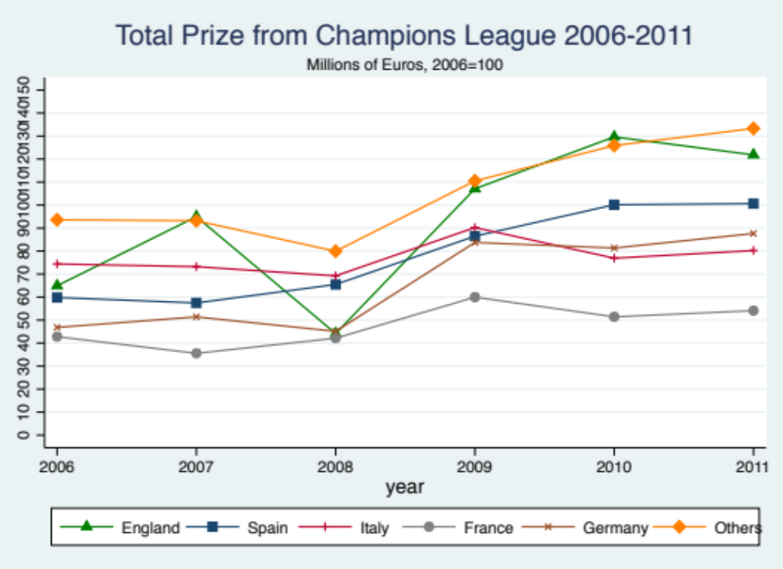
Figure 2
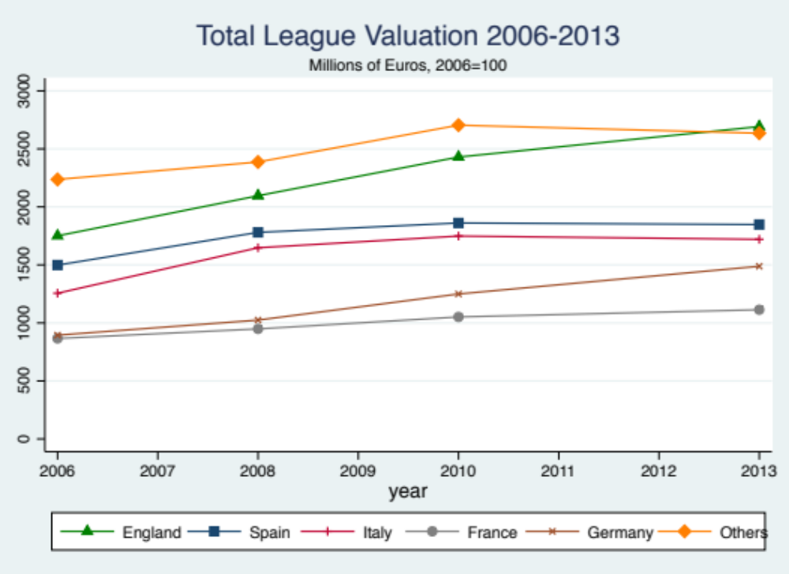

Payroll data is available for X countries (list), the correlation coefficient between payroll data and transfer market team valuations is 0.91. Hence, we argue that our valuation data captures most of the variation that exists in the payroll information.
For an economic assessment of the football transfer market as a matching process, where transfer fees are compensation payments for loss of an asset, see Terviö (2006)
Frick uses player valuation data from Kicker magazine but close inspection shows that Kicker valuations and transfermarkt valuations used here are closely correlated. Franck and Nüesch (2012) showed that Kicker and transfermarkt valuations had a correlation coefficient of 0.89 in their study of Bundesliga players between 2001 and 2006.
As different rounds are associated with different earnings it may be important to differentiate between teams that qualify directly to the group stage and teams that qualify into the earlier rounds. Our results are consistent if for example, we use the following rule that gives each team a fifty per-cent chance of advancing to the following round: Spots=Groups+.5Playoffs+.25Third+.125Second+.0625First.

